伯马机械产品说明书

BM-120D全自动鞋楦注塑机
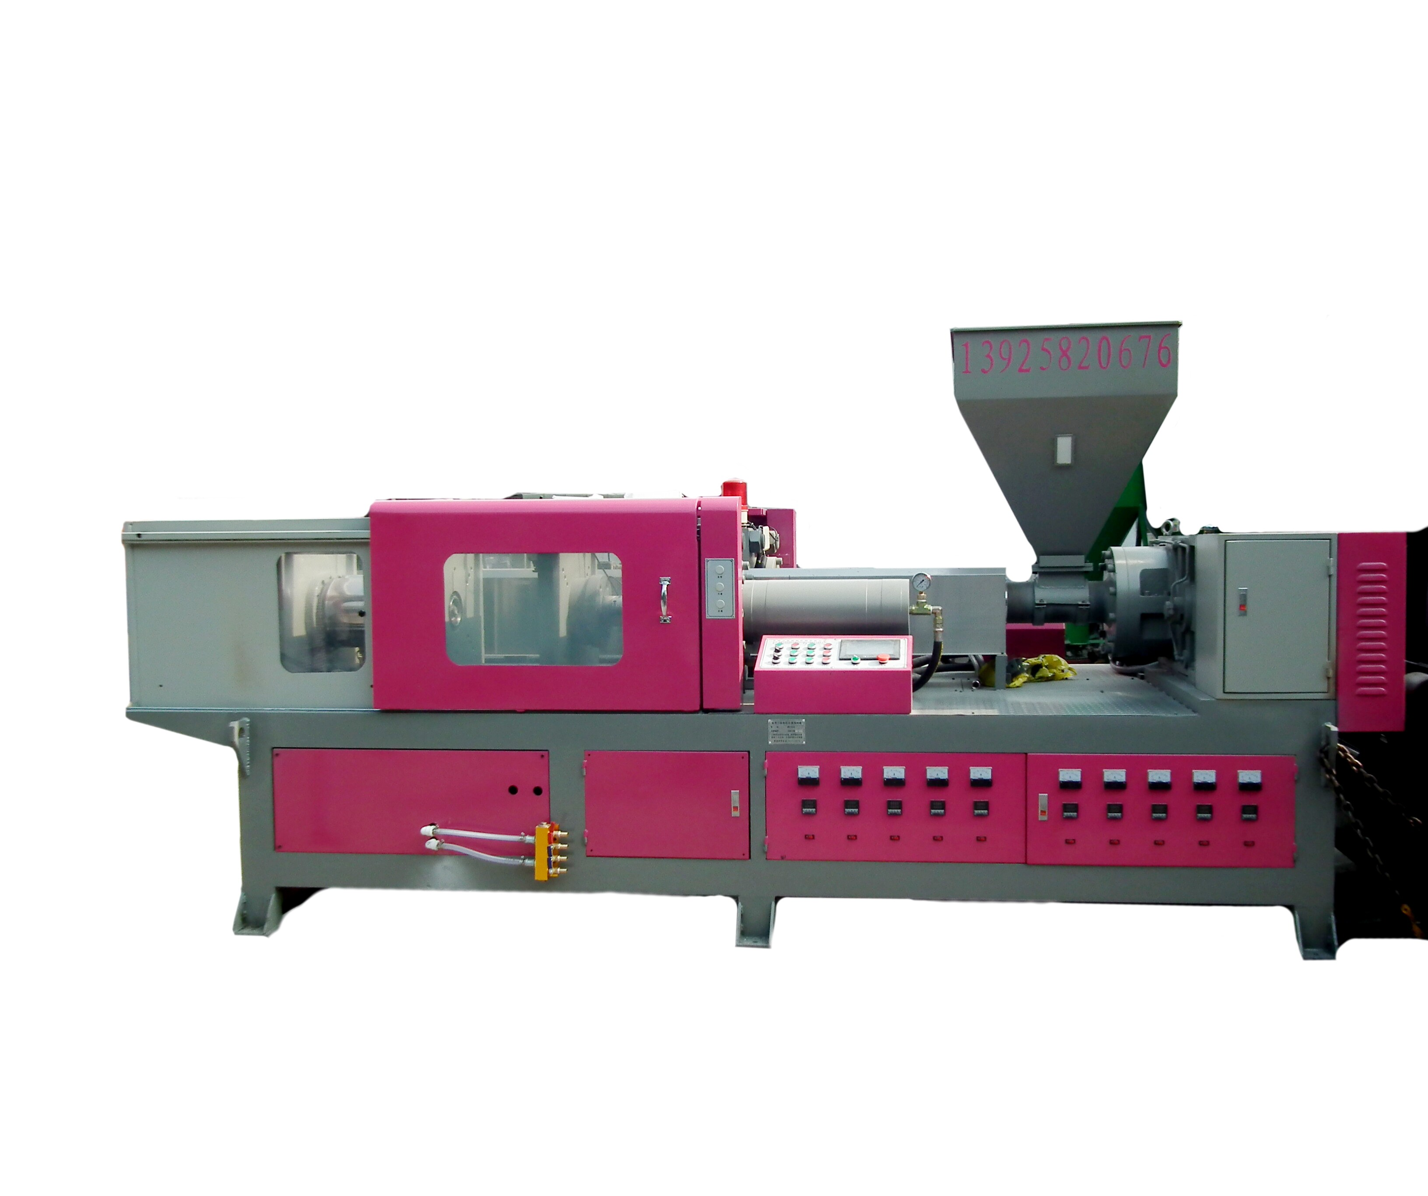

DongGuangBoMaMACHINERY CO,LTD

Preface

Thank you for using BOMA-120D injection molding machine last Burma

BOMA-120D energy-saving servo automatic injection molding machine is a new type of shoe last injection molding machine of our development, the machine adopts servo drive control circuit, in the product packing case, the pump motor is stopped, save electricity and increase the service life of the machine,

The machine adopts PLC control, touch screen display all analog signal output and input, input signal monitoring of all switches, abnormal alarm alarm lamp, and text display, let the exception handling machine adopts Taiwan energy saving stick out a mile, the frequency motor and open-loop vector control variable frequency speed of the screw, set screw according to different materials speed, make the machine more efficient,

The machine adopts low noise square reducer, the connecting screw rod cone bearing design in the speed reducer, the speed reducer is driven by the rotation of the lubricating oil pump to each bearing all the lubricating oil circulating, to reduce friction reducer, speed reducer to reduce resistance.

Screw injection molding machine is the heart of the machine, carrier transport, melting, mixing, molding, metering and exhaust function, is a key factor affecting the quality of the selection of suitable plasticizing, screw and rod, can not only improve the plasticizing quality and shorten the molding cycle, improve production capacity, can also reduce the loss rate of bad products, and artificial power, is of great significance, Ming changed over time, and with the wise thing, burmah machine after years of exploration and consult more than at home and abroad screw design professionals, according to the analysis and study of HDPE plastic material, design more energy efficient screw,

The company reserves the right to the continuous improvement of the machine, without notice

Catalog

The 1

Directory 2

Safety precautions 3

Machine installation 4

The operation of the machine 5

6 temperature setting

Speed setting 7

Time setting 8

The pressure set 9

Input monitoring 10

Output monitoring 11

The boot process 12

Shutdown process 13

Daily maintenance

The content of this paper 1.1

In handling and installation. Operation and maintenance before, please read the instructions, and follow all safety matters in the specification. If ignored, may cause personal injury or equipment damage.

Damage injury and equipment caused by your company or the customer does not comply with the instructions of the safety precautions, the company will not undertake the responsibility

1.2 definitions of safety information

Risk; failure to comply with the relevant requirements, it will cause serious personal injury, and even death,

A warning; if not comply with the relevant requirements, possible damage of equipment

Trained and qualified professionals; refers to the operation of the equipment personnel must undergo professional training, familiar with equipment operation and maintenance, and can avoid all kinds of emergencies.

Warning signs
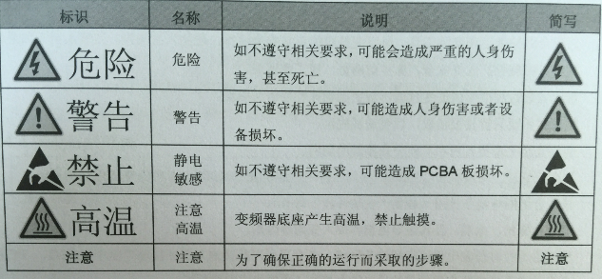
3
U
V
W
N
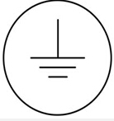
Machine installation

The size of the machine is 4600 wide and 1800 high 2500 times, a length greater than the installation site of the machine, the width on both sides have safety distance of 1200, convenient machine repair and maintenance,

The machine should be installed at the school administration level Four, general installation height in the best 50mm,

The machine is filled with 68# antiwear hydraulic oil 200L before use, and 220# gear oil, 50L,

The machine to install another cooling tower for oil and mold cooling machine. Cooling water machine is a machine, cooling circulating waterway has been installed in the factory, the factory installed, as long as the installation of a water inlet and a water outlet, a machine with 25 tons of water tower is the best.

The machine electric power contains the maximum power is 55kW, heating coil, in the normal work of the electric power is about 27KW, the installation wire should be copper wires with the national standard of 25 square above, for three-phase five wire, three-phase 380V and 220V phase, and ground frequency is 50HZ, the machine must be installed in the use of ground wire before. Note; professional electricians must install and debug,
The operation of the machine

Computer boot screen, click on the screen to set the parameters

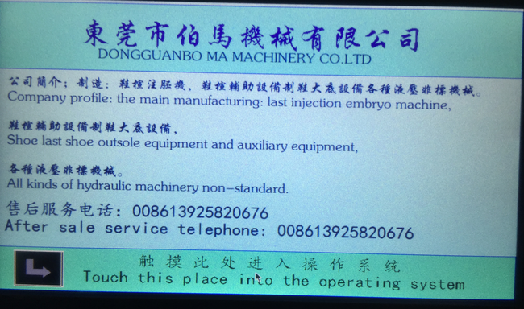
Temperature switch machine,

Click to open the machine temperature, temperature of heating temperature is only beginning computer switch function, to set the temperature setting on the thermostat, to set the desired temperature according to the actual material, with temperature control instructions, general temperature at 160 degrees to 210 degrees. The temperature does not reach the host can not start the set temperature
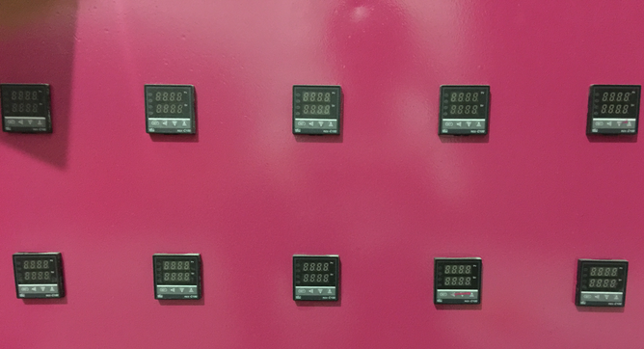

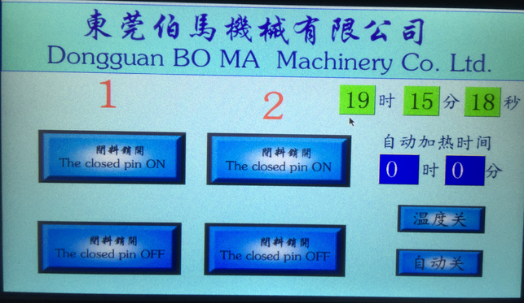

If you use the automatic heating function, we must first put the automatic heating function key for opening, and then to set the heating time; use automatic heating, the computer can not be closed
6
Speed setting, time setting, feeding set
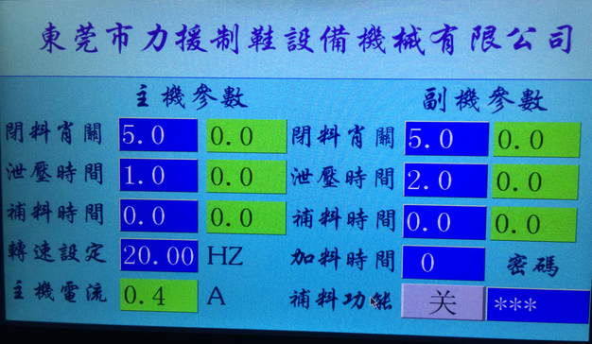
Set the speed position on the screen to set the frequency, changing the screw speed, speed range of 40HZ to 60HZ. To set different speed according to different materials, are generally full of shavings feeding speed is set to 60HZ, set the 50HZ particle and particles of each half, all is generally set as particles, 40HZ. The above data are for reference only, the actual speed is set according to the material

Time setting

Time setting general factory have already set. Rarely used in the process of customers, the closed pin off time refers to the closing pin insertion time, generally set at between 2 to 5 seconds, according to the size of the pressure setting, the pressure setting time is shorter, less pressure set a long time, mainly to the closed pin insertion to the last position shall prevail,

The relief time setting

The relief time refers to the mold after the completion, in order not to let the mold open up, to the moment the clamping pressure is reduced, usually set between 1 to 3 seconds.

Feeding function

Feeding function is mainly aimed at the last two shrink feeding, in order to make the last of the higher density, and smaller shrinkage, this function can be in the injection is completed, in time to mold injection, so as to enhance the density of shoe last. According to the last size set feeding time, the greater the last set feeding time is larger, the smaller shoe set time is small, generally set at between 3 to 10 seconds.

The closed pin manual switch

The screen in 1 and 2, 1 on behalf of the host, 2 representative vice machine, simulation button in the screen is pin manually open and close control of the auxiliary machine, generally used in the repair process,

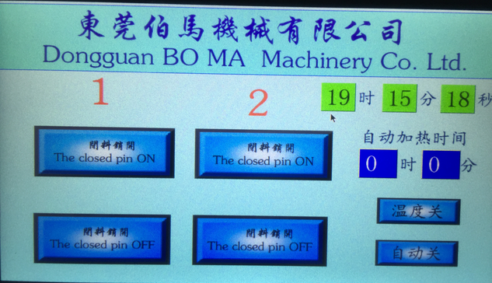

Input and output control

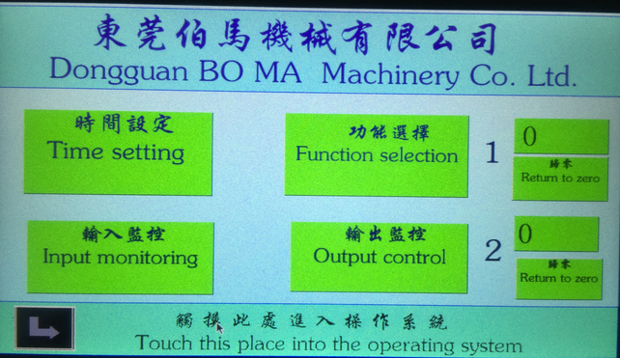
Click the input monitor page will display the input switch working state of all, on behalf of the red input, black represents no input,

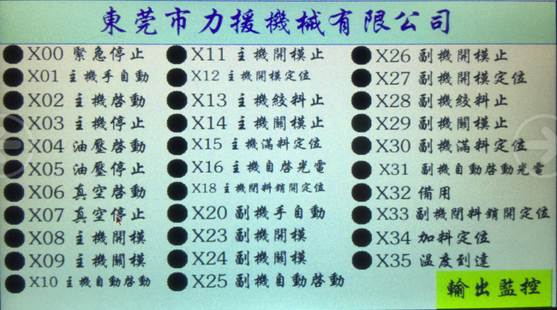

Output monitor

Click on the page will display the output output monitoring working state of all, on behalf of the red black represents no output output,
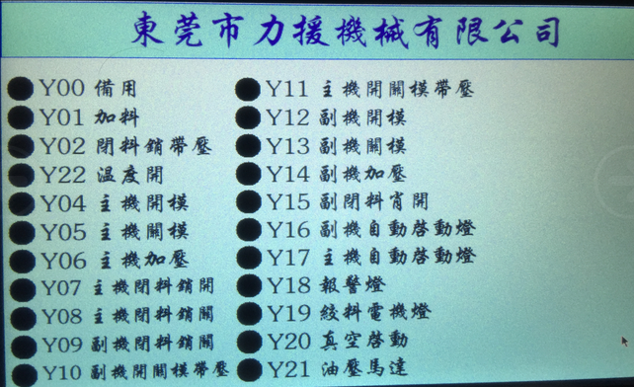
The back pressure valve main and auxiliary machine

Clockwise adjust the pressure increase, the opposite direction by pressure decreases.

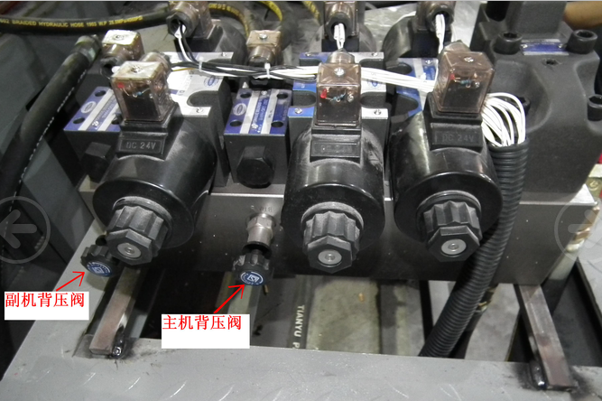
The clamping pressure setting

Clockwise pressure, reverse direction pressure decreases, the pressure of the mold is generally set to 90 150KG.

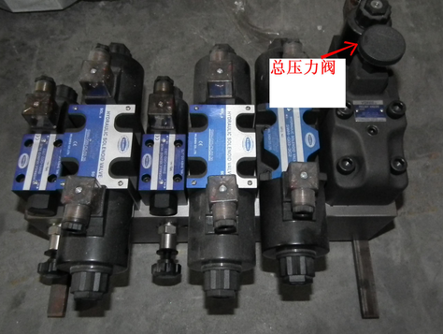

The boot process

The first step, open the machine, open the machine temperature heating, temperature to start the pump, manual mode, the manual storage barrel in all material extrusion, in the main and auxiliary machine mold end, then the main machine are selected automatically, in accordance with the automatic start, automatic press start 1, interval after 3 seconds, the lamp lights in the host to start automatically activated by 2. Check whether there is a vacuum port after starting material out, after cleaning. Cover the vacuum cover, press the vacuum can be started. As in the boot process out abnormal function, make the main machine manual, side clamping end, and then the main machine is open in the end, re start automatically once, the program will automatically resume.

Shutdown procedures

The first step to stop, the main and auxiliary machine manual, stop the vacuum pump, and then manually extrusion in the material storing tube material, mold to the middle position, heating in turn off the machine, turn off the power.

Daily maintenance

Vacuum pump oil and filter replaced once a month

Gear oil changed every 12 months

The hydraulic oil replaced once every December
.

